

Govan HELP
Employability Worker Application Pack
August 2026

May 2025

Dear Applicant,

Thank you for your interest in the role of Employability Worker at Govan Home and Education Link Project (Govan HELP).

We are a growing place-based family support charity, established in 1996, that aims to improve the opportunities and outcomes for vulnerable children and families living within the Govan area. We offer a range of integrated, early intervention services to support children and families who are experiencing cumulative and chronic adversity.

Govan HELP has been supporting families in the Govan community for almost 30 years and we have a strong strategic plan to grow our core services., making this an exciting time to join our team. We are looking for a dynamic, solutions focused and trauma informed Employability Worker to continue the delivery of our service. To meet the needs of the Govan community the postholder will require to be flexible in approach and able to manage the workload with a combination of community based and remote working practice, working in partnership with key stakeholders.

Included in the pack is a Job Description and Person Specification to assist you with completing your application. If you would like to apply for the post, please send a CV and covering letter, outlining how your skills and experience are suited to the role, to Lindsay Galloway, Operations and Performance Manager, on lindsay.galloway@govanhelp.org by 28th August at 5pm. Please feel free to contact us for an informal conversation about the role prior to application.

This is an excellent opportunity for the right candidate to join us to deliver this important service for families in the Govan area and we look forward to receiving your application.

Yours sincerely,

Viv Sawers
Chief Executive Officer

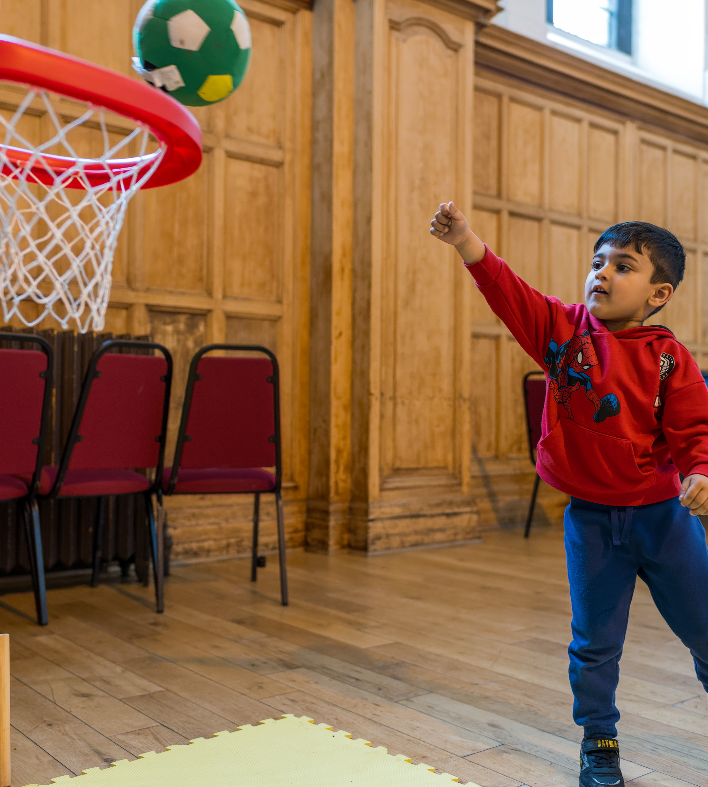
Job Description: Employability Worker

Job Title: Employability Worker

Hours: 35 per week

Salary: £28,000

Contract: Full-Time | 2 years Fixed Term

Responsible To: Lindsay Galloway Operations & Performance Manager

Job Purpose
The Employability Worker will deliver volunteering and employability support to parents, carers and individuals experiencing barriers to employment, education and training.
Embedded within Govan HELP’s wider family support model, the role will ensure employability support is integrated alongside counselling, wellbeing, financial advice and practical family support services. The postholder will work flexibly and compassionately with individuals who may be far from the labour market, supporting them to build confidence, develop skills and progress at a realistic pace towards positive destinations.
This role is central to Govan HELP’s place-based approach to tackling child poverty and strengthening outcomes for families across the Govan community.

Key Responsibilities
Employability Support
- Deliver tailored one-to-one employability support to parents, carers and community members
- Support individuals to identify strengths, aspirations and achievable goals
- Develop personalised action plans with participants
- Support CV building, applications, interview preparation and job searching
- Assist individuals to access training, volunteering and employability opportunities
- Work closely with volunteers and create more opportunities

Volunteering Development & Coordination
• Support the development and coordination of volunteering opportunities across Govan HELP services
• Recruit, support and maintain positive relationships with volunteers
• Identify meaningful volunteering pathways that build confidence, skills and progression opportunities
• Work with volunteers to support service delivery across groups, community activities and the Pantry
• Promote volunteering as a stepping stone towards employability, training and social connection
• Support volunteers to identify strengths, gain experience and progress towards positive destinations
• Maintain volunteer records and contribute to monitoring and reporting on volunteer engagement and outcomes

Barrier Identification & Support
- Identify barriers impacting employability including:
  - poverty
  - trauma
  - mental health challenges
  - caring responsibilities
  - low confidence
  - financial hardship
  - skills gaps
- Work collaboratively with internal services to ensure participants receive holistic support

Group Work & Community Engagement
- Deliver group-based employability and confidence-building sessions
- Facilitate work-readiness and personal development activities
- Undertake outreach across the Govan community to engage individuals furthest from employment
- Build trusting relationships within the local community
Partnership Working
- Develop pathways with employers, training providers and employability agencies
- Work collaboratively with schools, housing providers, third sector organisations and community partners
- Promote volunteering and supported progression opportunities
Outcome Monitoring
- Maintain accurate records and contribute to monitoring and evaluation processes
- Support reporting on outcomes and impact
- Track participant progress and sustainment outcomes

This job description is not intended to be exhaustive. The post-holder will be expected to adopt a flexible attitude to the duties, which may have to be varied subject to the needs of the service and in keeping with the general profile of the post. This post is exempt from the Rehabilitation of Offenders Act 1974 by the Exclusions and Exemptions (Scotland) Order 2003, and as such any appointment will be subject to them having appropriate PVG Scheme Membership.

Person Specification
Essential
- Experience supporting individuals facing barriers to employment
- Understanding of poverty, trauma and social exclusion
- Experience delivering one-to-one support and group work
- Strong communication and relationship-building skills
- Ability to motivate and empower others
- Knowledge of employability pathways, training and local support services
- Ability to work collaboratively within a multi-disciplinary team
- IT skills and ability to maintain accurate records
Desirable
- Experience within the third sector or community-based services
- Understanding of trauma-informed practice
- Experience supporting parents and families
- Knowledge of the Govan community and local challenges
- Relevant qualification in Community Development, Employability, Social Care or related field

Values & Approach
The successful candidate will demonstrate:
- Compassion and empathy
- A non-judgemental approach
- Commitment to tackling inequality and child poverty
- Flexibility and creativity
- Belief in people’s potential
- Commitment to relational and place-based working

Why This Role Matters
By supporting parents, carers and volunteers towards employment, education and training, the Employability Worker will help strengthen household stability, improve wellbeing and contribute to better long-term outcomes for children and families.
This role reflects Govan HELP’s belief that tackling child poverty requires whole-family, community-led and relational approaches that support people to move beyond surviving to thriving



